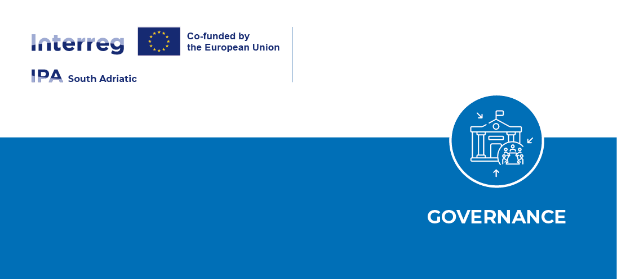
UNIVALENS
UNIVALENS
Overcoming Cross-border Educational Programs Recognition and Equivalence
limitations

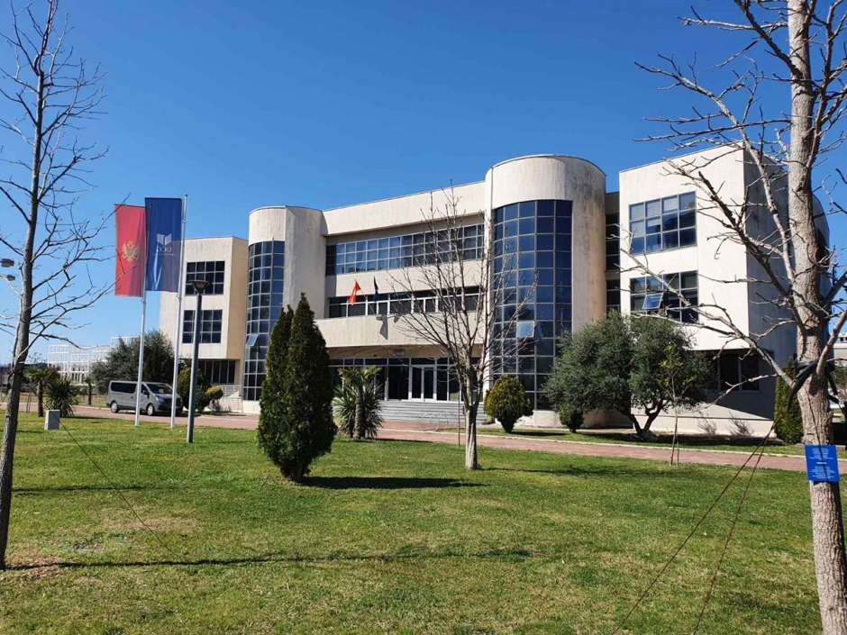

“Procedures and Recommendations for the development
of higher education programs in Montenegro”
Activity 1.3 Workshop

Managing Board Hall
University of Montenegro
7.03.2025
Podgorica

WORKSHOP AGENDA
Managing Board Hall University of Montenegro
7th of March 2025

h 8.30 – 09.00
Registration
h. 09.00 | Prof. Ph.D. Nedeljko Latinović – Director of the Institute for Interdisciplinary and Multidisciplinary Studies, University of Montenegro – Welcome Speech
Contents and inputs | - The joint challenges for the new developments toward the joint study programs in Creative Industries – by Prof. Edin Jašarović – Dean of the Faculty of Dramatic Arts  - Quality Assurance Control Mechanism and Processes at UoM, by Ph.D. Svetalana Perović, President and the Director of Quality Assurance Centre of UoM  - Challenges of the accreditation processes of Higher education Joint Study programs: Montenegrin case – by Mrs. Tamara Đuričković – Assistant Director of the Agency for Control and Quality Assurance of Higher Education of Montenegro (ACQAHE)
Expected output | - New knowledge acquisition
h. 11.30 | Coffee Break
h. 12.00 | Prof. Ph.D. Sara Vojošević – Jovanović, Vice – Dean for International Collaboration – Faculty of Dramatic Arts, University of Montenegro
Contents and inputs | - Designing the programs for audio-visual education – by Ph.D. Prof: Nikola Vukćević – Head of the study program Film and Media, Faculty of Dramatic Arts  - Interdisciplinary approaches to possible doctoral study program in arts – by prof. Ph.D. Zdravko Delibašić, Vice- dean for teaching, Faculty of Fine Arts  - Artistic Research in Higher Education: Challenges, Experiences, and Perspectives - by Ph.D. Jelena Martinović - Bogojević, member of the Quality System Management Committee of UoM in the field of Arts
Expected output | - New knowledge acquisition
h. 14.00 | - Lunch Break
h.15.30 | Prof. Janko Ljumović – Faculty of Dramatic Arts, University of Montenegro - Moderator
Contents and inputs | - Training modules offers – by Prof. Ph.D. Vuk Vuković, member of the Managing Board of University of Montenegro  - Sharing the “rules of the game”  - Working groups and final round table
Expected output | - New knowledge acquisition
h. 17.00 End of the Workshop



